Diagram Of Tabular Model:

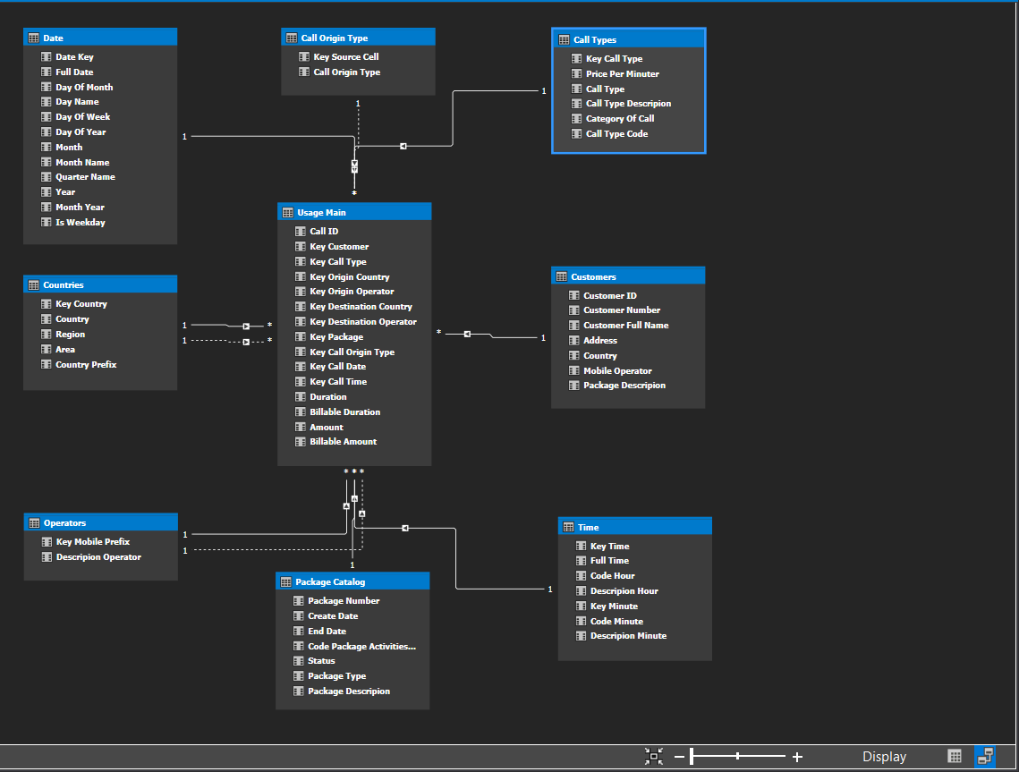

That Relationship Of Tables:

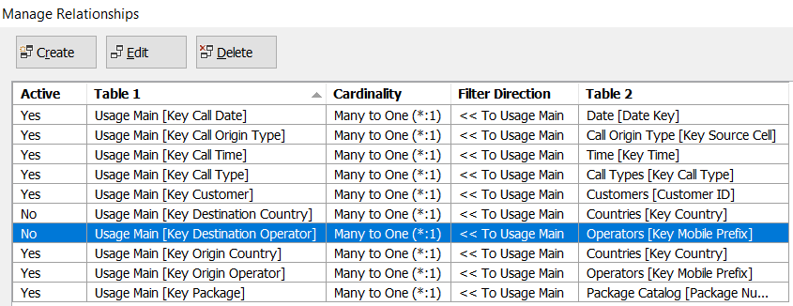

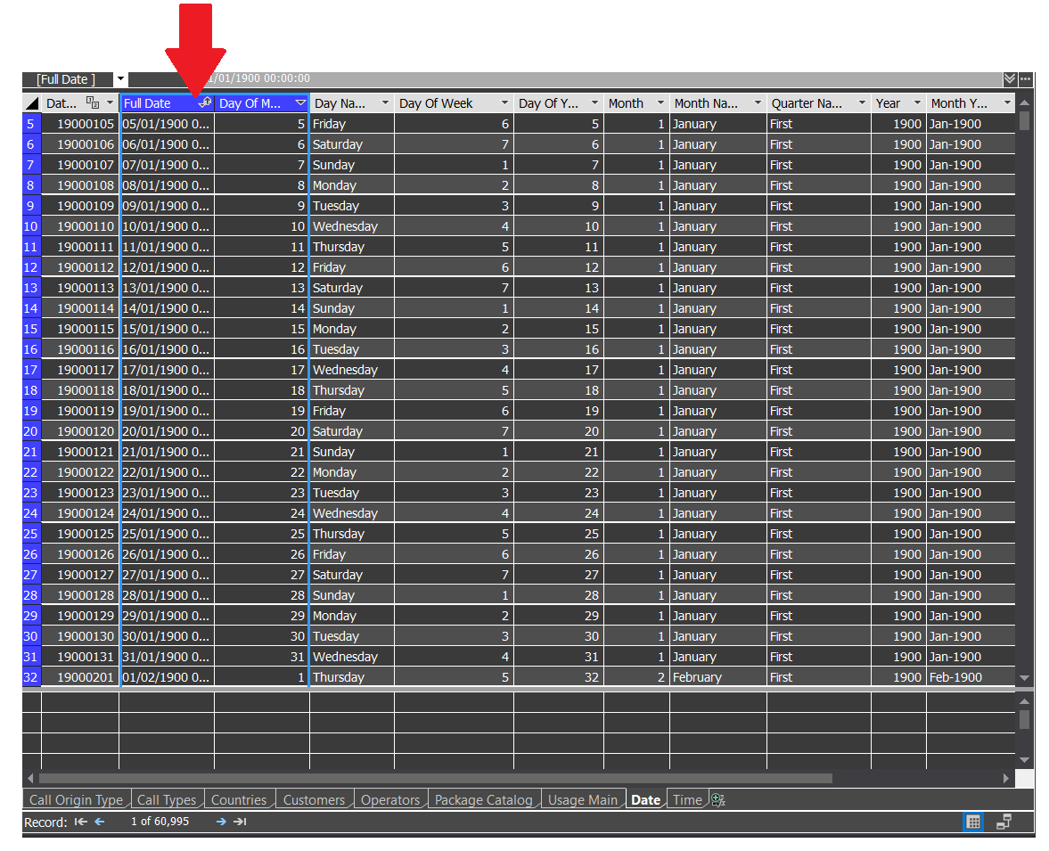Sort Active Of Date Table:

The Calculated Columns (Grey Columns):

We created two computed columns using the DAX language.

* The first column is Discount. Writing the calculation is:

Discount : = 'Usage Main'[Amount] - 'Usage Main'[Billable Amount]

* The second column is Discount Percentage. Writing the calculation is:

Discount Percentage : = 'Usage Main'[Discount] / 'Usage Main'[Amount]

We are changed the format of calculated column Discount Percentage in properties (without a number after a point)

